 | Order Form Customer:  Address |  | TO : Paper King Date :  Tel :  Email:
No. |  | commodities /packing |  | Unit Price | Per Box | Quantities
1 | 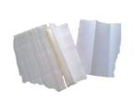  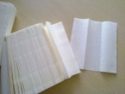 | N Fold Hand Towel  200sheet/pack x 20/box |  | 50 | 50
2 | 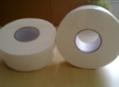   | JUMBO TOILET ROLL (2-Ply)  800g 300m/roll x 12/box |  | 4.33 | 52
3 |  | CENTRE FEED HAND TOWEL  1500g 200m/roll x12/box |  | 9 | 108
4 | 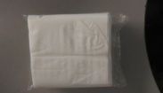 | Serviette 2-ply 10*19CM  13.5g100sheets/pack x 200/box
5 | 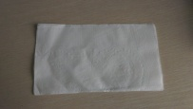 | Dinner Serviette40*40  22g  200sheets/pack x 20/box |  | 106 | 106
6 | 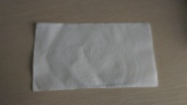 | Dinner Serviette 40*40  19g200sheets/pack x 20/box |  | 80 | 80
7 |  | Dinner Serviette(2-Ply) 40*40  16.5g200sheets/pack x 20/box |  | 98 | 98
8 |  | Luncheon Serviette( 2-Ply) 28*28  16.5g100sheets/pack x 48/box |  | 98 | 98
9 |  | Luncheon Serviette 28*28  22g100sheets/pack x 48/box |  | 85 | 85
10 |  | 80*80 (2 ply) Cash Register paper roll 10rolls/pack x 5/box |  | 8 | 80/pack
11 |  | 80*80 thermal roll 50rolls/box |  | 2.5 | 125
12 | 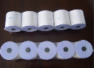 | 57*50 thermal roll 100rolls/box |  | 0.6 | 60
13 | 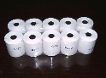 | 57*38 Thermal roll 100rolls/box |  | 0.55 | 55
 | Sub Total
Remark: all price are exclueded GST.

www.paperking.co.nz

